## Introduction

Uniform flowdown after deceleration may return clearer plasma by reducing shear at the plasma-cell pack interface. During deceleration, the plasma is pulled down by gravity, but is prevented from advancing down the weir by the work required to wet the weir surface. Instead, the liquid bulges near the bottom until building hydrostatic pressure overcomes the wetting resistance. Often, the plasma flows down the weir slope in 1-3 locations, providing a wetted surface for the rest of the plasma to flow over down into the collecting area. We think that a hydrophilic weir surface may present a smaller surface energy barrier, permitting more uniform flowdown.

The extent to which the weir surface is affected by contact with the blood is unknown. Vroman showed that small proteins, such as antibodies, adhere rapidly to surfaces and are eventually displaced by proteins with greater affinity for the surface [cite]. Some proteins bind irreversibly [protein rinsing paper]. Furthermore, studies on plasma protein adsorption onto polymeric surfaces suggest that adsorbing proteins (be more specific?) orient their most polar regions toward a polar surface [cite]. Consequently, the more hydrophobic regions of a protein orient toward the air, providing more resistance to wetting. We investigated the effect of plasma exposure on polymer wettability by measuring the contact angles of water and plasma on glossy and matte surfaces coated by human plasma.

## Materials and Methods

1-inch square wafers were printed using the Stratasys printer using 2 photocurable resins. The body of a printed object is a stiff, cross-linked polymer. An object that uses only the body resin has a “glossy” finish. Separation disks include overhanging material, so a water-soluble support resin is also used in the printing. This support material is washed out using a water jet before the disk may be used, but complete removal of the support material requires extensive washing with water. Consequently, disks that have been used more or that have not been reproducibly cleaned contain residual support material. Any disk surface printed with the support materials is rough and opaque and is referred to as “matte”, regardless of how clean it is. Glossy wafers were printed to simulate hydrophobic polymers used in injection molding, such as polypropylene. Matte wafers were printed to simulate the weir slopes of the spinning disks.

The contact angles of water and plasma were measured by placing a 2-4 uL drop on the wafer surface using a 10 uL Hamilton syringe and capturing an image with a goniometer (type and model). The drop volume was adjusted to maximize the drop size, while keeping the entire drop inside the camera field of view. No significant difference between drop size and contact angle was discovered (see SI). (Come back to drop size and location…) Contact angles were measured using the Contact_angle plugin for imageJ (developed by _). Plasma was obtained from a female donor and warmed to room temperature before experiments.

Plasma proteins were coated onto the wafer surfaces to simulate the coating process in the disk. First, 200 uL of plasma was pipetted onto a wafer and allowed to sit for 1 minute. Excess plasma was pipetted off and the remaining was allowed to dry at room temperature for 5-10 minutes. This is denoted as “Coated”. In the second treatment, 200 uL of plasma was pipetted onto a wafer over 20 seconds; the wafer was plown on by an air jet for 3 minutes (duration of a spinning experiment) to remove excess and dry the plasma coating. This is referred to as “blown 3 min”. Third, a wafer was subjected to a strong air jet as 200 uL of plasma was pipetted onto the surface. The plasma immediately blew off and the wafer stayed in the air jet for 1 minute. This is referred to as “Quick dry”. After taking contact angle measurements on a coated wafer, the wafer was scrubbed by hand with a wet Kimwipe and allowed to air dry. This is denoted as “wiped.”

## Results

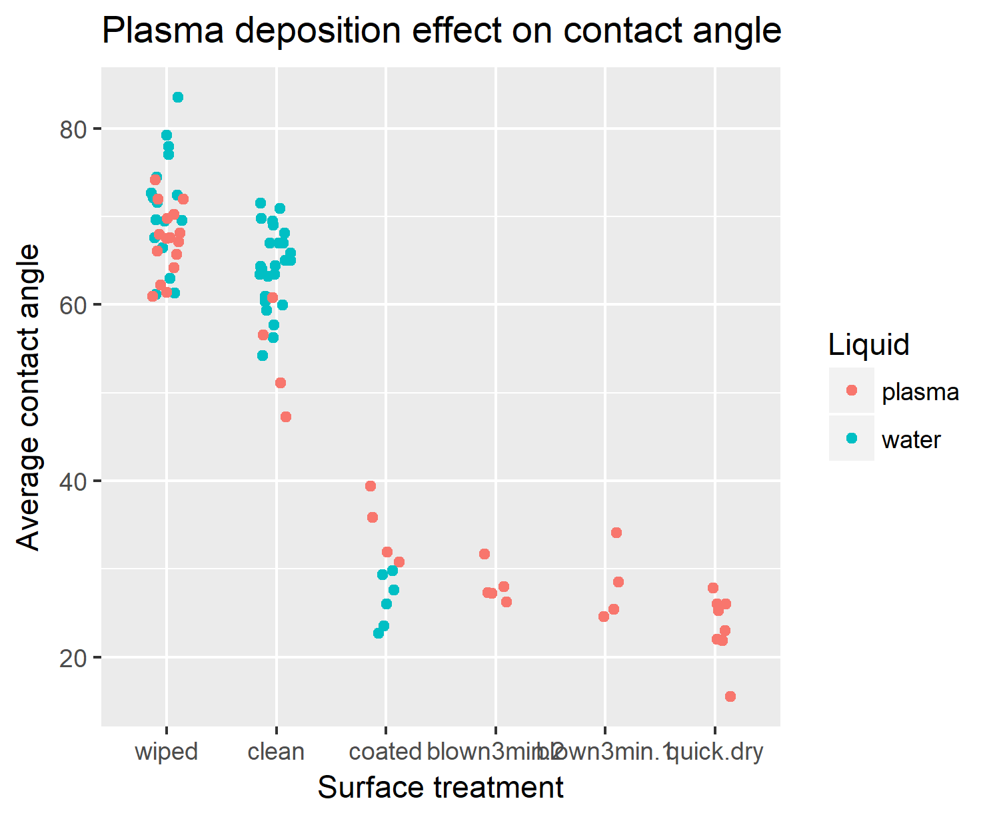The contact angles measured on a glossy finish are displayed in Table 1 and Figure 1. On a clean surface, the water had a greater contact angle than plasma ( $64.1±4.5°$ and $53.9± 6°$, respectively, p<0.05) because of its polarity. Decreasing the plasma-wafer contact time increased the wettability of a glossy surface. The thick coating in treatment 1 decreased contact angles for water and plasma as each droplet solvated the plasma coating. Particularly, water droplets are unsaturated by proteins, so they likely had a lower contact angle than the plasma because they dissolved more of the plasma coating. The thickness of plasma coating in treatment 1 (~0.5mm) overshadowed any potential effect of surface adhesion.

To more accurately replicate the short liquid-surface contact time in a spinning experiment, treatment 2 was applied and found to maintain a low contact angle ($28.1°$). The surface was twice coated and wiped to determine the efficacy of the wiping procedure. The coated surface was nearly identical for each treatment application. The wiped surface actually became more hydrophobic (water: $71.1±6.2°$, plasma: $53.9±6°$) than the original clean surface (p<0.05), indicating that the plasma coating may be removed from a disk through mechanical abrasion. Treatment 2 gave a qualitatively thinner coating than treatment 1, but seemed to over-estimate the contact time experienced in an actual spinning experiment. Treatment 3 did not leave a film of visible thickness, but its contact angle remained low ($23.4±3.9°$). This suggests that short contact times are sufficient to increase the wettability of a hydrophobic surface.

|  |  |  |  |  |  |
| --- | --- | --- | --- | --- | --- |
| **Liquid** | **Treatment** | **n** | **Average angle** | **SD** | **SE** |
| plasma | wiped | 16 | 67.3 | 3.8 | 1 |
| plasma | clean | 4 | 53.9 | 6 | 3 |
| plasma | coated | 4 | 34.5 | 3.9 | 2 |
| plasma | blown3min.1 | 4 | 28.1 | 4.3 | 2.2 |
| plasma | blown3min.2 | 5 | 28.1 | 2.1 | 0.9 |
| plasma | quick.dry | 8 | 23.4 | 3.9 | 1.4 |
| water | wiped | 17 | 71.1 | 6.2 | 1.5 |
| water | clean | 26 | 64.1 | 4.5 | 0.9 |
| water | coated | 6 | 26.5 | 3 | 1.2 |

**Matte surface – what happens here? – need to process data. Explain that hydrophilic support material is very wettable.**

## Discussion

Thin plasma coatings increase surface wettability for hydrophobic disk materials. For matte surfaces, the plasma coating doesn’t make a big difference because the support material increases the disk wettability to about the same extent. It seems like we need a polymer that will wet fast and stay wetted longer…

Experiments:

* Dissolve support onto glossy. Check dynamic and equilibrium angles for water (n=8), then plasma (n=8). Use wafer A. Can a hydrophilic polymer wet a glossy surface?
* Get matte initial and equilibrium values
* Can I print a disk with a glossy weir and glue the lid on?
* Bigger question: if the weir is in contact with liquid, why does it not flow down uniformly?
* Is plasma behavior transferrable to blood?
* Which wets faster: paa or support?